

| **1. APT Project Progress Summary** |
| --- |
| Below, you will find different fields that you must complete with the requested information. |

| APT Project Progress Summary | In the documentation phase, the main required deliverables have been completed, including the identification of stakeholders, the risk matrix, and the corresponding system diagrams.  In terms of development, the application already includes its main page, the login module, and the main user view once logged in, which corresponds to the client environment. These advances have helped shape the overall functionality of the system and visualize how the next components will be connected.  So far, it has not been necessary to modify the initial objectives or methodology, although small adjustments were made in the distribution of tasks to facilitate progress during this stage.  Overall, the project is in a stable phase, with concrete progress in both documentation and platform development, leaving the team well positioned to continue with the remaining tasks for the next delivery. |
| --- | --- |
| Objectives | *No adjustment* |
| Methodology | *No adjustment* |
| Evidence of Progress | As evidence of the project’s progress, the documentation developed to date is presented, which includes several system diagrams, along with the implementation of the login module and the main user view.  These pieces of evidence demonstrate progress both in the documentation and in the technical development of the system, reflecting the proper application of planning and methodologies. In addition, the quality of the work has been ensured through the team’s internal organization, constant review of deliverables, and the use of collaborative tools such as Notion, Google Drive, and GitHub, which guarantee traceability and project control. |

**kanban board**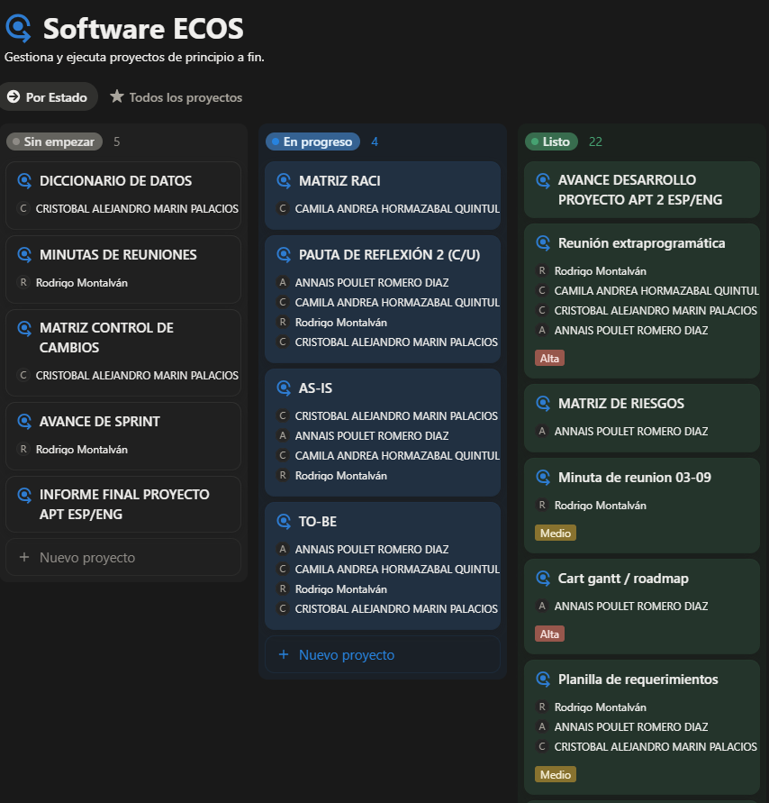

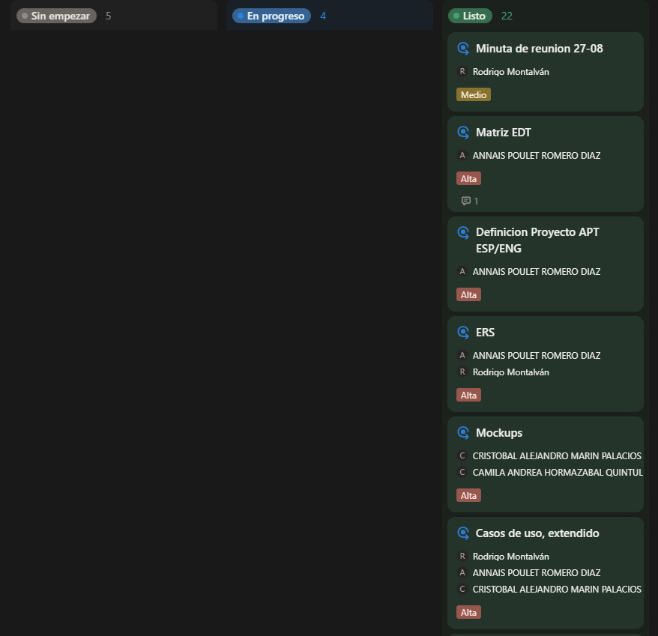

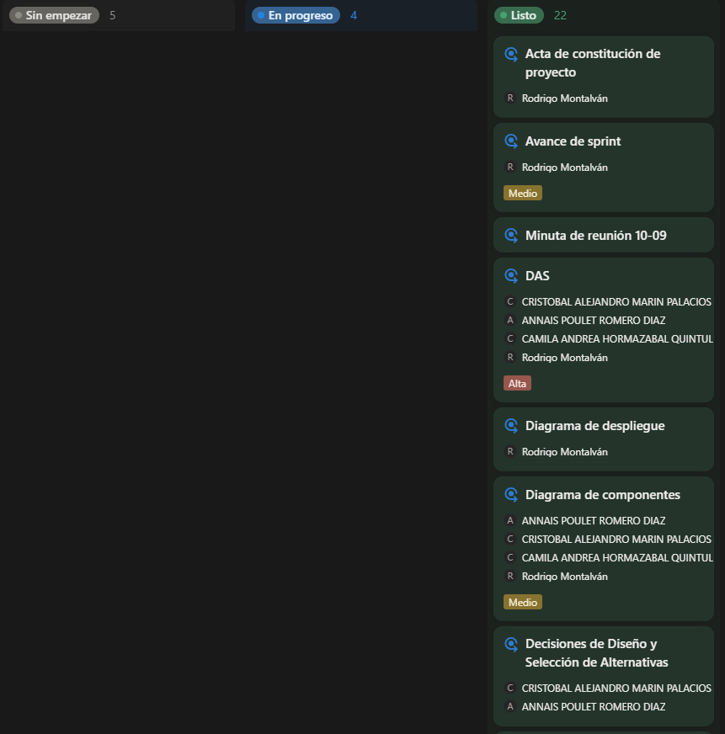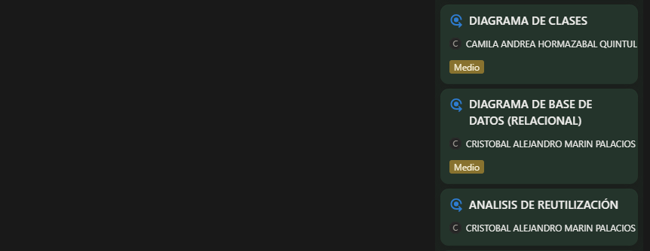

**Folder containing the documents**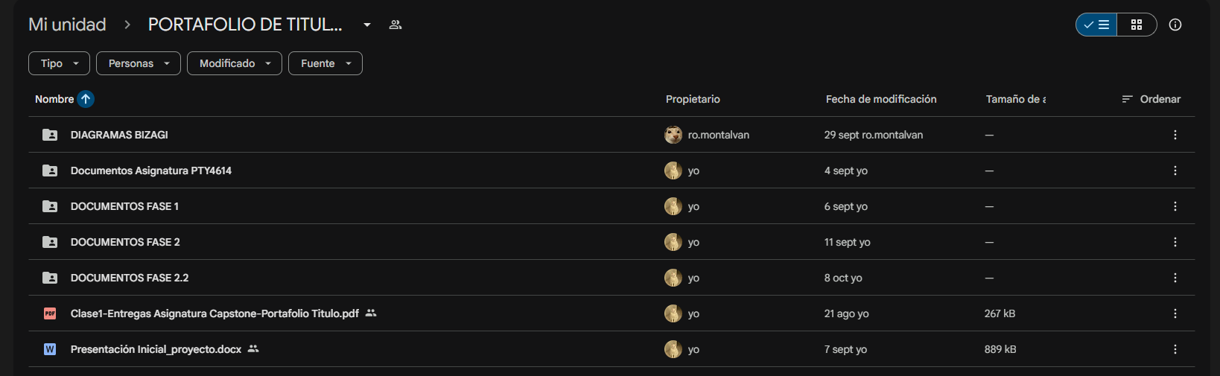

**Access to DAS (System Architecture Document):** <https://docs.google.com/document/d/1O1_JyuPpJvAWMeLoawzmAzx7jADeIOKW/edit?usp=sharing&ouid=117094630181580503329&rtpof=true&sd=true>

**Deployment diagram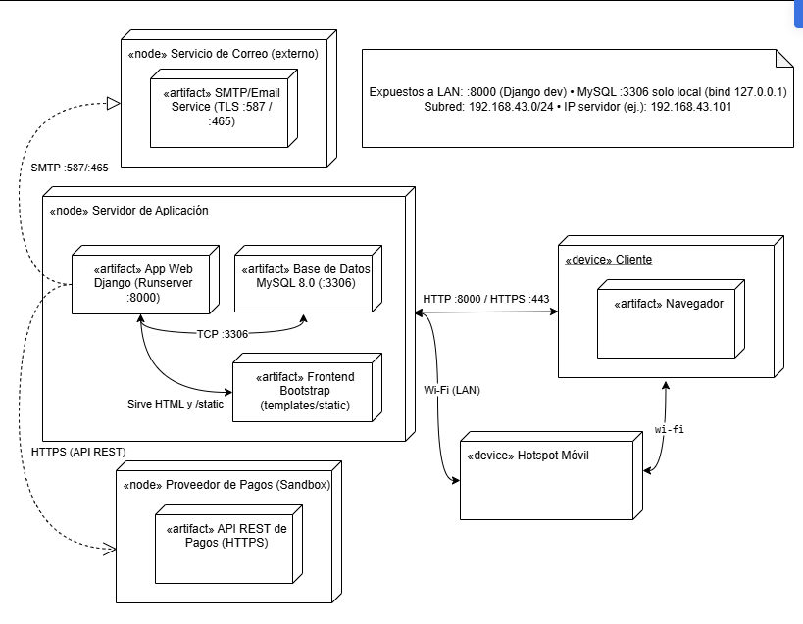Component diagram**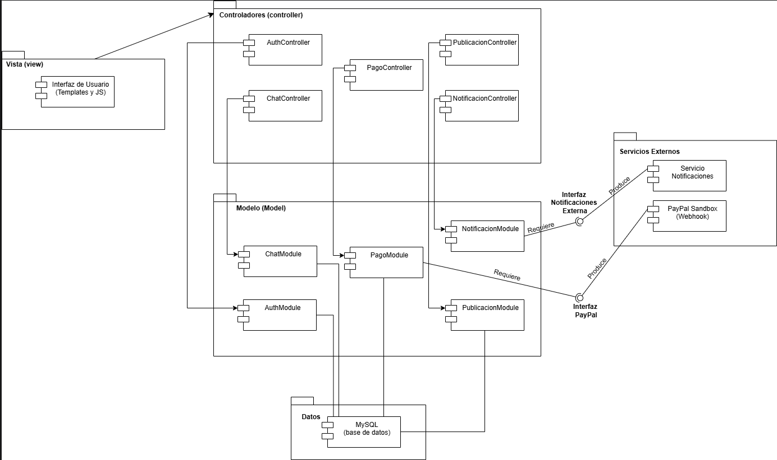

**Sequence diagram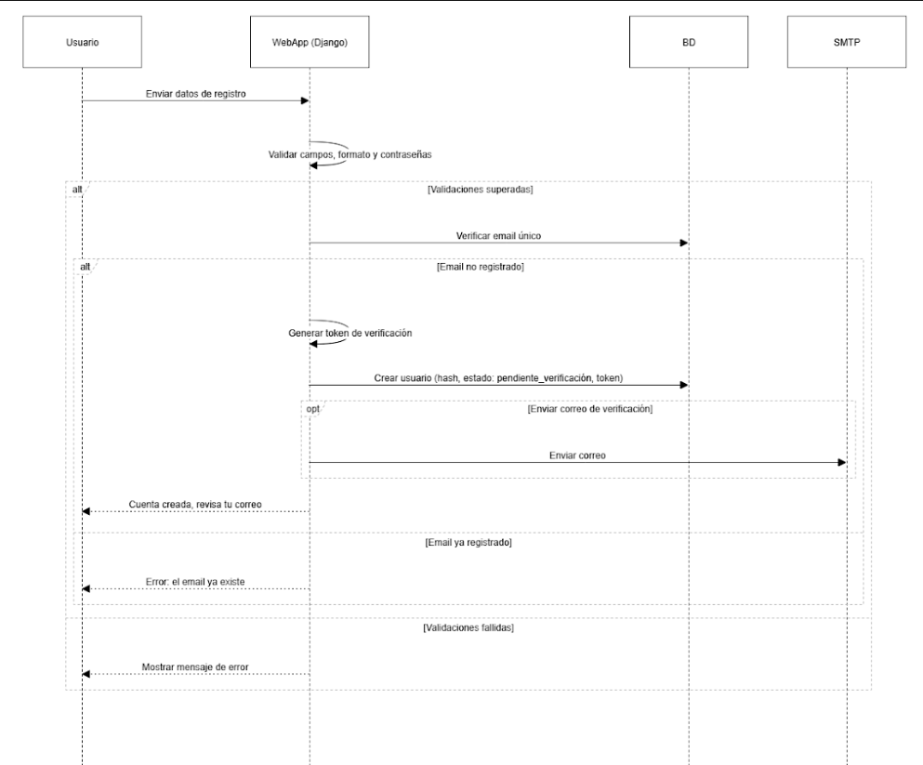Class diagram**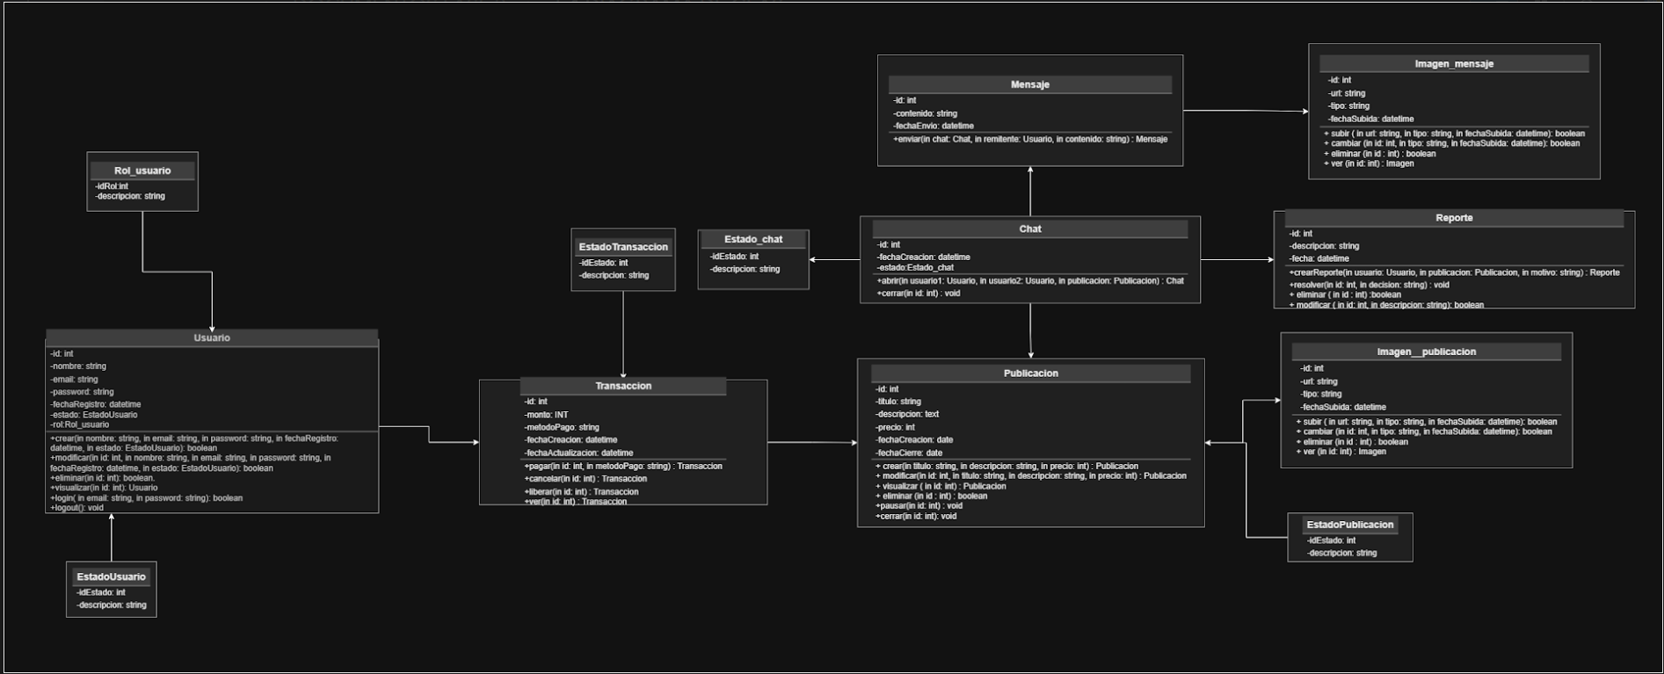

**Risk matrix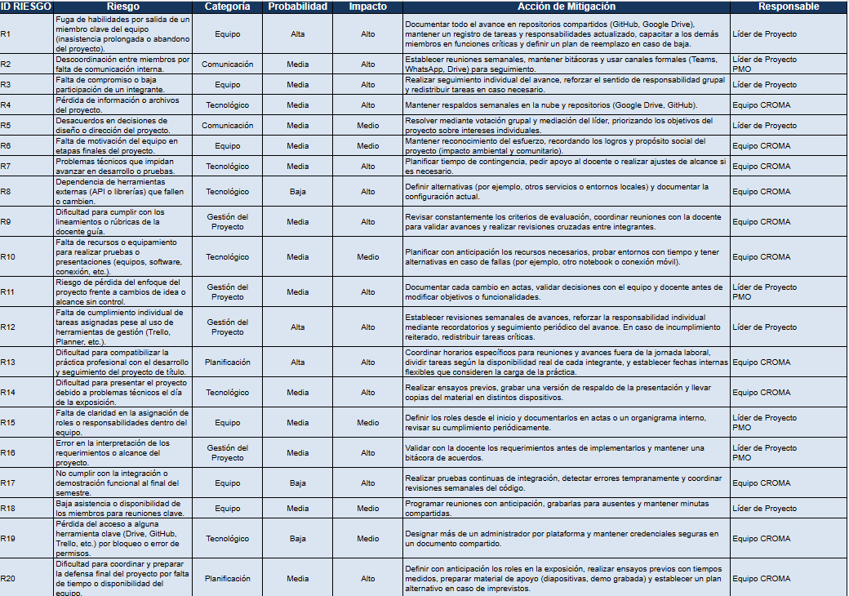Principal view**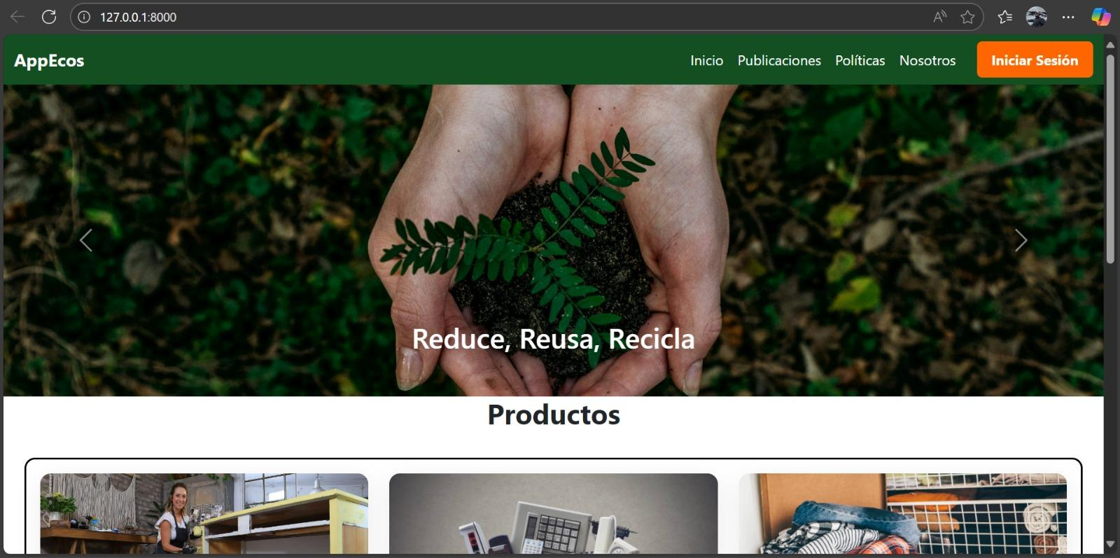

**Login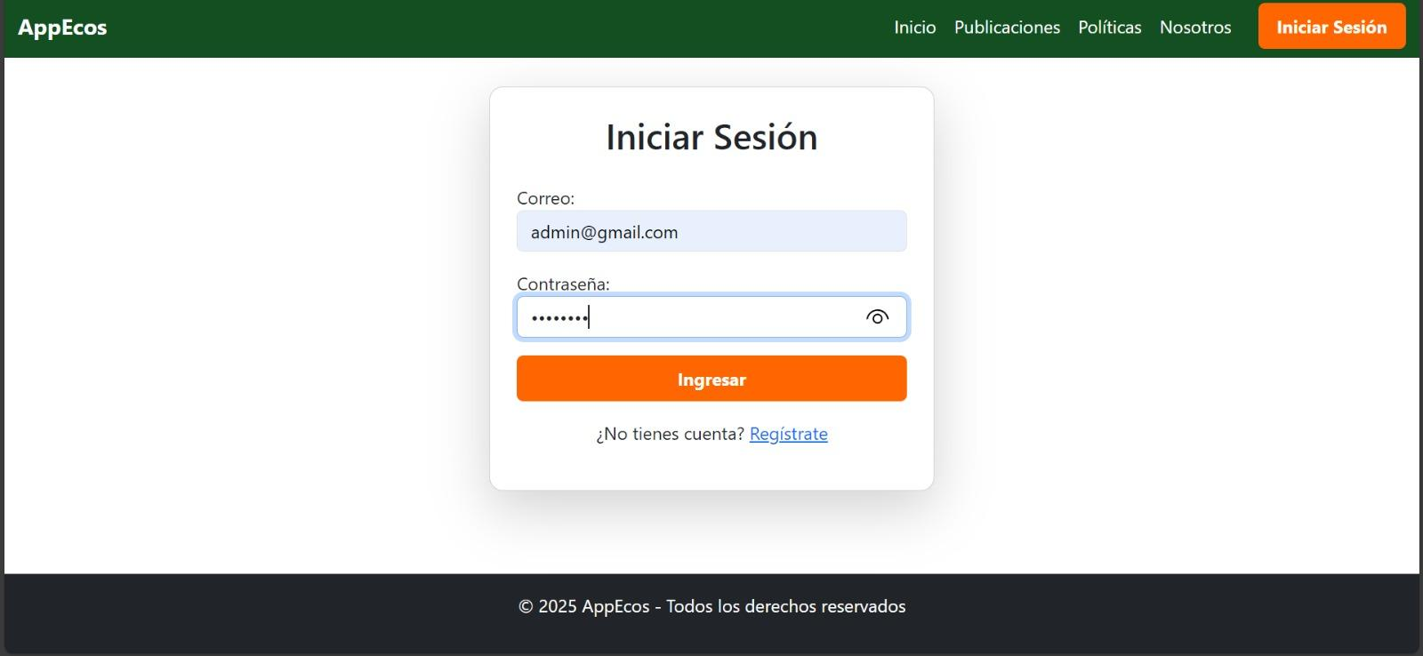Create account**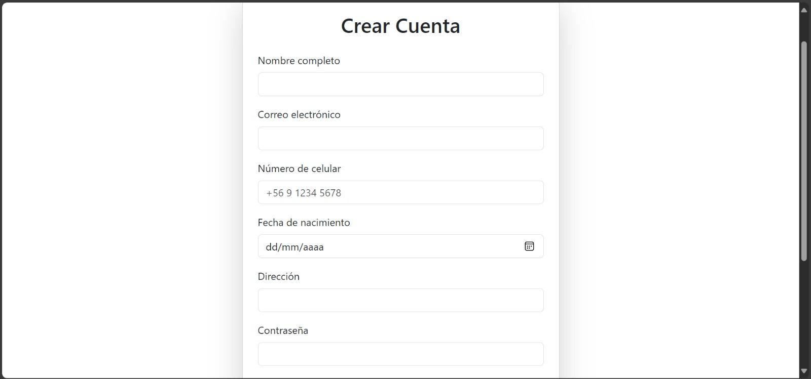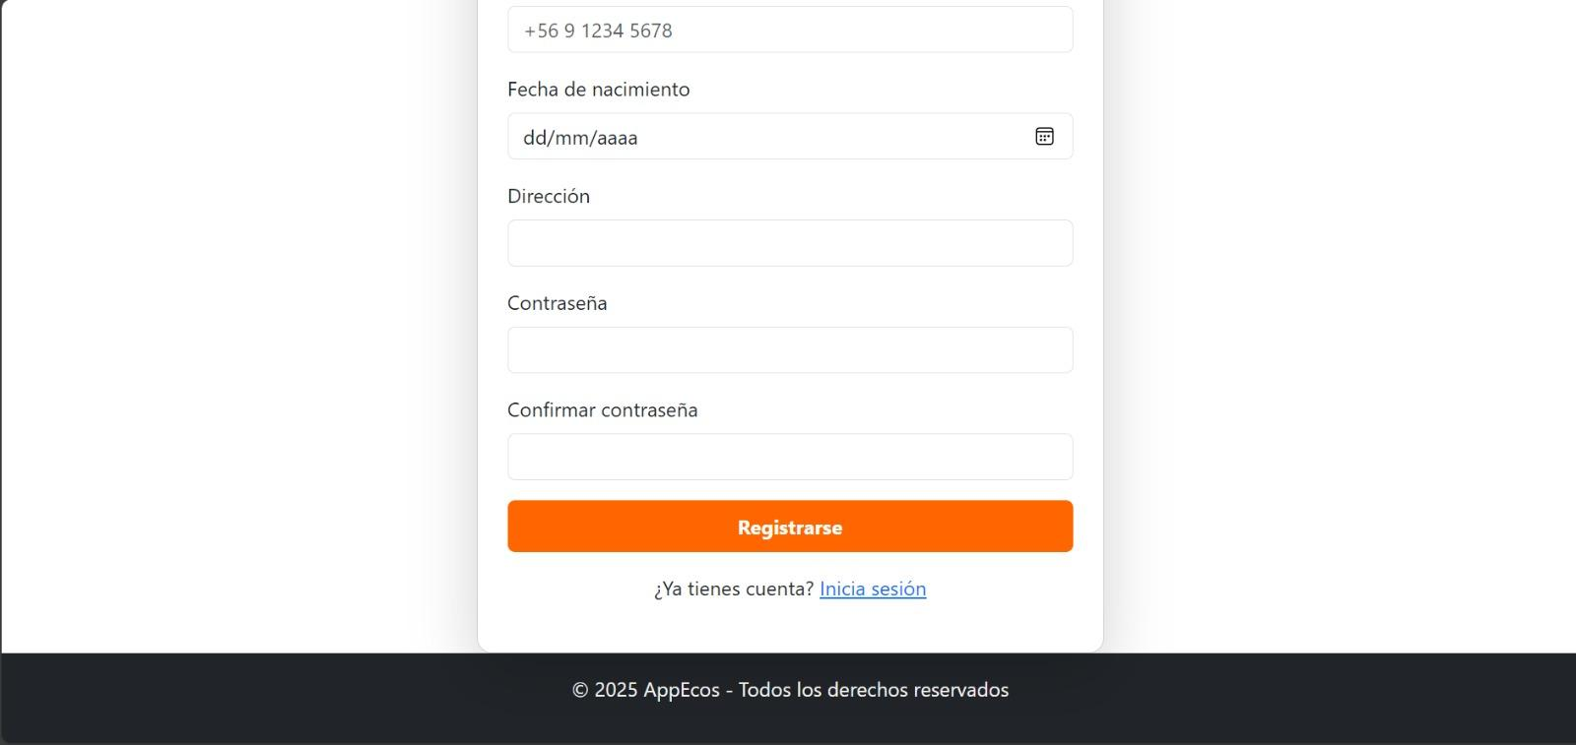

**Posts and filters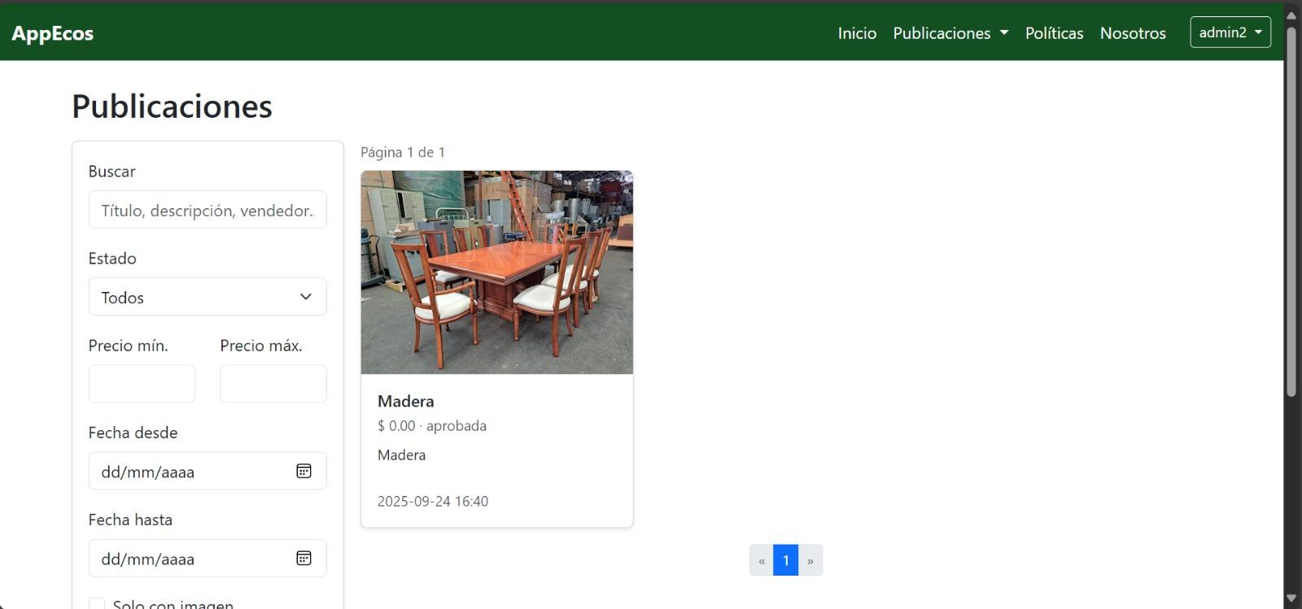My posts (not published yet)**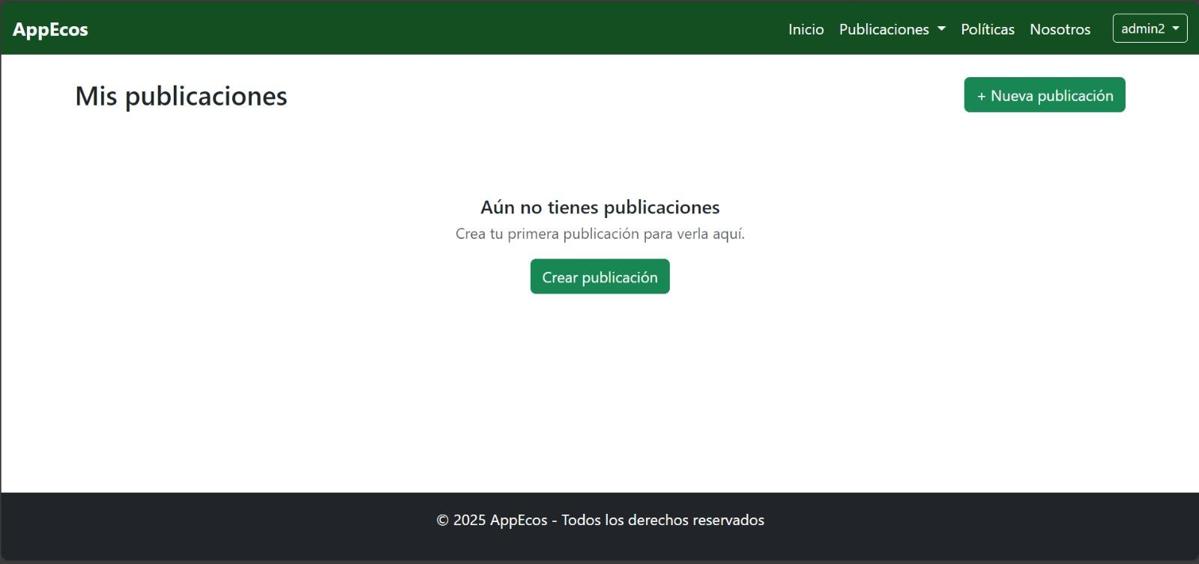

**My posts (with publication)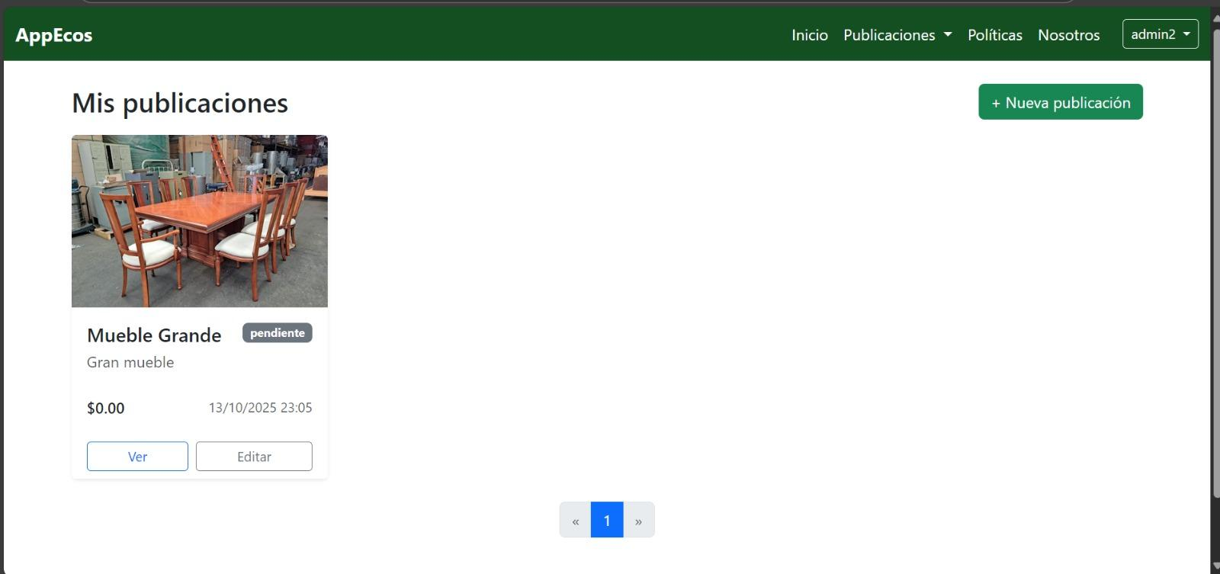Create new post**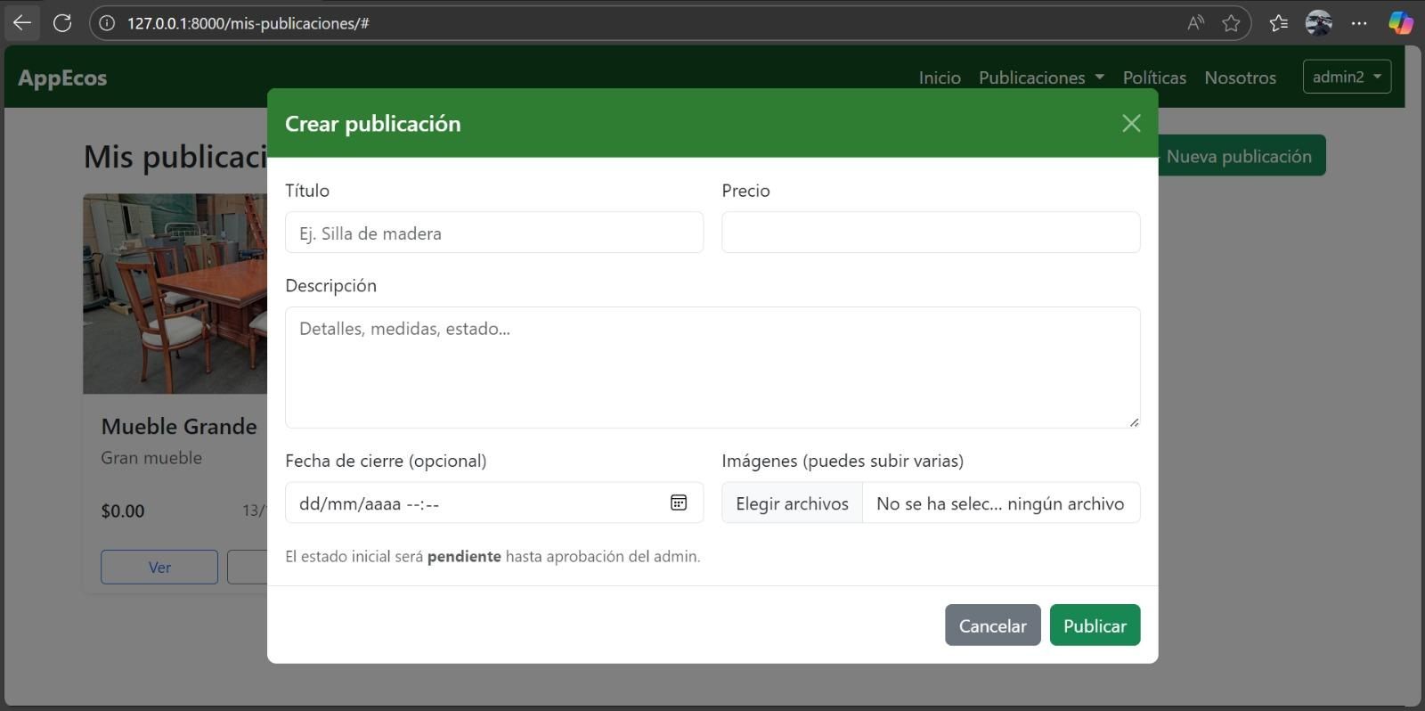

| **2. Work Plan Monitoring** |
| --- |
| Carefully review your work plan, focusing especially on the “progress status” and “adjustments” columns. |

| Work Plan | | | | | | | |
| --- | --- | --- | --- | --- | --- | --- | --- |
| Competency or Unit of Competencies | Activities | Resources | Duration of the activity | Responsible | Observations | Progress Status | Adjustments |
| **Manage IT Projects** | **Project Charter** | Word, team meetings | Sprint 1. | Annais Romero  Rodrigo Montalván | Base document depending on the initial team agreements and project context. | *Completed* | *-* |
| **Design and Adapt Requirements Processes** | **Requirements (FR/NFR)** | Requirements spreadsheet, Excel | Sprint 1. | Annais Romero  Rodrigo Montalván.  Cristóbal Marín. | May require adjustments after validation with the instructor. | *Completed* | *-* |
| **Design Software Solutions** | **Initial ERS** | Word, ERS Guide, Excel | Sprint 1. | Annais Romero  Cristóbal Marín | Highly iterative document; complemented in later phases. | *Completed* | *-* |
| **Design Software Solutions** | **Extended Use Cases** | Word | Sprint 1. | Rodrigo Montalván | Must be validated together with functional requirements. | *Completed* | *-* |
| **Design Software Solutions** | **Develop Technical Documentation System Mockups** | Balsamiq | Sprint 1. | Cristóbal Marín  Camila Hormazabal | Facilitates early validation of the proposed software’s usability. | *Completed* | *-* |
| **Manage IT Projects** | **WBS Costs** | Excel | Sprint 1. | Annais Romero | Serves as the basis for financial planning. | *Completed* | *-* |
| **Design Innovative and High-Quality Software Solutions** | **Architecture Document (DAS Part 1)** | Word, UML, Lucidchart/Draw.io | Sprint 2. | Cristóbal Marín  Annais Romero | Must be approved before development. | *Completed* | *-* |
| **Design and Adapt Software Engineering Processes** | **TO-BE Processes** | Bizagi | Sprint 2. | Rodrigo Montalván  Annais Romero  Cristóbal Marín  Camila Hormazabal | Must be validated by the instructor and reviewed by the team. | *In progress* | *-* |
| **Design and Generate Solutions that Meet Information Requirements** | **Data Dictionary** | MySQL, Excel | Sprint 2. | Cristóbal Marín | Essential for maintaining consistency in subsequent software development. | *In progress* | *-* |
| **Evaluate and Manage IT Projects** | **RACI Matrix** | Excel | Sprint 2. | Annais Romero | Requires team consensus. | *In progress* | *-* |
| **Evaluate and Manage IT Projects** | **Risk Matrix** | Excel | Sprint 2. | Rodrigo Montalván | Active document; will be updated throughout the project. | *Completed* | *-* |
| **Develop Software Solutions Using Good Coding Practices** | **Login/Registration + Initial Maintainers (users, roles, categories)** | Django, MySQL, Bootstrap, GitHub | Sprint 2. | Cristóbal Marín | Critical foundation for the remaining functionalities. | *Completed* | *-* |
| **Evaluate and Manage IT Projects** | **Change Control Matrix** | Excel | Sprint 2. | Cristóbal Marín  Camila Hormazabal | Ensures project traceability. | *In progress* | *-* |
| **Develop Innovative Software Solutions for Web Platforms** | **Product Posting and Management** | Django, MySQL, Bootstrap | Sprint 3. | Cristóbal Marín  Camila Hormazabal | Validate business rules. | *Completed* | *-* |
| **Design and Generate High-Quality Software Solutions** | **Catalog with Filters and Search** | Django, MySQL, Bootstrap | Sprint 3. | Cristóbal Marín | Non-functional requirement: response time must be under 3 seconds. | *Completed* | *-* |
| **Build Complex Programs and Routines** | **Transactions (Sales/Donations with Sandbox)** | Django, MercadoPago Sandbox API | Sprint 3. | Cristóbal Marín | Risk due to dependency on external services. | *Not started* | *-* |
| **Design Secure and Reliable Software Solutions** | **Email Notifications** | Django, SMTP, mail server | Sprint 3. | Cristóbal Marín | Validate that emails are sent only to registered accounts. | *Not started* | *-* |
| **Design and Generate Innovative and Quality Solutions** | **Secondary Maintainers (statuses, payment methods, policies)** | Django, MySQL | Sprint 3. | Cristóbal Marín  Camila Hormazabal | Maintain consistency with previous DB and FR requirements. | *Not started* | *-* |
| **Design Data-Driven Software Solutions** | **Reports (sold products, transactions per period)** | Django, ReportLab/XlsxWriter libraries | Sprint 3. | Cristóbal Marín  Rodrigo Montalván | Validate filters and data consistency. | *Not started* | *-* |
| **Design and Generate Solutions to Meet Information Requirements** | **Database Script** | MySQL | Sprint 3. | Cristóbal Marín | Requires integrity and relational tests. | *Completed* | *-* |
| **Evaluate and Manage IT Projects** | **Scope Verification** | Checklist, Meeting Minutes | Sprint 3. | Annais Romero  Rodrigo Montalván | Prerequisite for QA in Sprint 4. | *Not started* | *-* |
| **Perform Software Certification Testing** | **Functional and Integration Tests** | Selenium, Unittest, Checklist | Sprint 4. | Rodrigo Montalván. | Expected success rate of 90% or higher. | *Not started* | *-* |
| **Build Complex Programs and Routines** | **Validate Data Solutions** | Database Test Matrix, Excel, MySQL | Sprint 4. | Cristóbal Marín.  Rodrigo Montalván. | Ensures database consistency and performance. | *Not started* | *-* |
| **Perform Software Certification Testing** | **Defect Log** | Excel, Defect Tracking Sheet | Sprint 4. | Rodrigo Montalvan.  Cristóbal Marín.  Camila Hormazabal. | Enables traceability and quality control. | *Not started* | *-* |
| **Develop Technical and User Documentation** | **User Manual and Training Plan** | Word, PowerPoint | Sprint 4. | Annais Romero.  Camila Hormazabal. | Ensures user adaptation to the system. | *Not started* | *-* |
| **Evaluate and Manage IT Projects** | **Final Report APT 2.0 (Spanish/English)** | Word | Sprint 4. | Annais Romero.  Rodrigo Montalván. | Requires team review before submission. | *Not started* | *-* |
| **Evaluate and Manage IT Projects** | **Effective Communication Final Presentation** | PowerPoint, Canva | Sprint 4. | Annais Romero.  Cristóbal Marín.  Rodrigo Montalván.  Camila Hormazabal. | Requires prior rehearsals and team coordination. | *Not started* | *-* |

| **3. Adjustments Based on Monitoring** |
| --- |
| Expand on the observations from your work plan. Analyze the planned activities and indicate which aspects facilitated or hindered the execution of the plan. Explain how you addressed or will address the obstacles. Finally, specify the adjustments you made to the work plan based on this analysis. |

| Factors that have Facilitated and/or Hindered the Development of My Work Plan:  What has facilitated the development of our work plan has been the internal organization we have maintained as a team, supported by the use of management tools such as Notion and Google Drive. These tools have allowed us to distribute tasks clearly and keep deliverables up to date. The fluent communication among team members has also been a key factor in resolving questions and coordinating progress, which has helped us meet the planned stages within the established deadlines.  Regarding the difficulties encountered, the main challenge has been understanding and defining how the PayPal payment API will be implemented, considering its configuration, testing, and integration with the system environment. To address this, the team decided to research the official documentation and review similar integration examples to ensure a correct implementation in the upcoming stages of development.  As for the adjustments made to the work plan, the only change has been the modification of the leadership role, made under the instructor’s guidance, by appointing a new project leader. |
| --- |

| Adjusted or Eliminated Activities:  So far, the ECOS project work plan has not required any adjustments or elimination of activities, as the planned tasks have been completed within the established timeframes and stages.  We believe this result has been possible thanks to the team’s internal organization, the constant use of management tools such as Notion and Google Drive, and the fluent communication among members. These factors have allowed for effective coordination, balanced task distribution, and continuous monitoring of progress.  Additionally, the initial planning was developed realistically, taking into account each member’s availability, which has made it easier to move forward without setbacks and maintain compliance with the proposed objectives. For this reason, it has not been necessary to make modifications to the activities or the structure of the original work plan. |
| --- |

| Activities Not Yet Started or Delayed:  So far, there are some activities that have not yet been started; however, this does not indicate a delay, as they correspond to the planned schedule. The ECOS project is currently in the execution phase of Sprint 3, so tasks such as scope verification, functional and integration testing, database validation, and final documentation are scheduled for the upcoming stages.  The team has decided to maintain the original plan, as progress remains within the established deadlines. As a strategy, continuous monitoring will be carried out to ensure that the pending activities are developed without setbacks and within the defined timeframes. |
| --- |